**SQL EXERCISE**

**Database: SHOPPING**

**Table: Salesman**

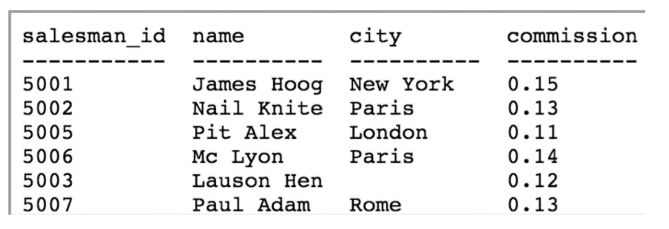

**Table: Customer**

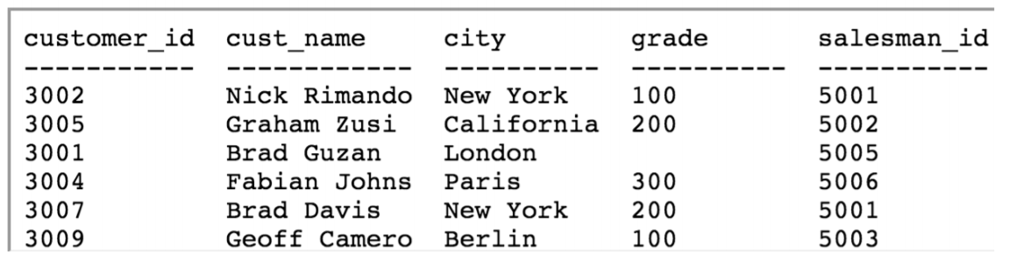

1. Write a query to display all customers with a grade above 100.

SELECT * FROM CUSTOMER WHERE GRADE > 100;

1. Write a query statement to display all customers in New York who have a grade value above 100.

SELECT * FROM CUSTOMER WHERE CITY=”New York” AND GRADE > 100;

1. Write a SQL statement to display all customers, who are either belongs to the city New York or had a grade above 100.

SELECT * FROM CUSTOMER WHERE CITY=”New York” OR GRADE > 100;

1. Write a SQL statement to display all the customers, who either belong to the city New York or not had a grade above 100.

SELECT * FROM CUSTOMER WHERE CITY=”New York” OR GRADE < 100;

1. Write a SQL query to display those customers who neither belong to the city New York nor grade value more than 100.

SELECT * FROM CUSTOMER WHERE CITY !=”New York” OR GRADE < 100;

1. Write a SQL statement to display either those orders whose are not issued on date 2012-09-10 and issued by the salesman whose ID is 505 or those orders whose purchase amount is below 1000.00.

SELECT * FROM ORDER WHERE (ISSUE_DATE != “2012-09-10” AND SALES_ID = 505) OR AMOUNT < 1000;

7. Write a SQL statement to display salesman_id, name, city and commission who gets the commission within the range of 0.10% to 0.12%.

SELECT SALESMAN_ID,NAME,CITY, COMMISSION FROM SALESMAN WHERE COMMISSION BETWEEN 0.10 AND 0.12;

8. Write a query to filter those salesmen with all information who come from any of the cities Paris or Rome.

SELECT * FROM SALESMAN WHERE CITY IN (“Paris”,”Rome”);

9. Write a SQL statement to find those salesmen with all information who get the commission within a range of 0.12 and 0.14.

SELECT * FROM SALESMAN WHERE COMMISSION BETWEEN 0.12 AND 0.14;

10. Write a query to filter all those orders with all information which purchase amount value is within the range 500 and 4000 except those orders of purchase amount value 110.5 and 948.50.

SELECT * ORDER WHERE AMOUNT BETWEEN 500 AND 4000 AND AMOUNT != 110.5 AND AMOUNT != 948.50;